Invoicing & Collection

Table of Contents

1. Fee Charge 1
2. Trade Fee Setup 3
3. Invoicing / Maintenance 5
4. Invoicing Listing Report 7
5. Invoice Settlement 8
6. Bank Transaction 9

Fee Charge

- Create fee charge via Fee Charge screen
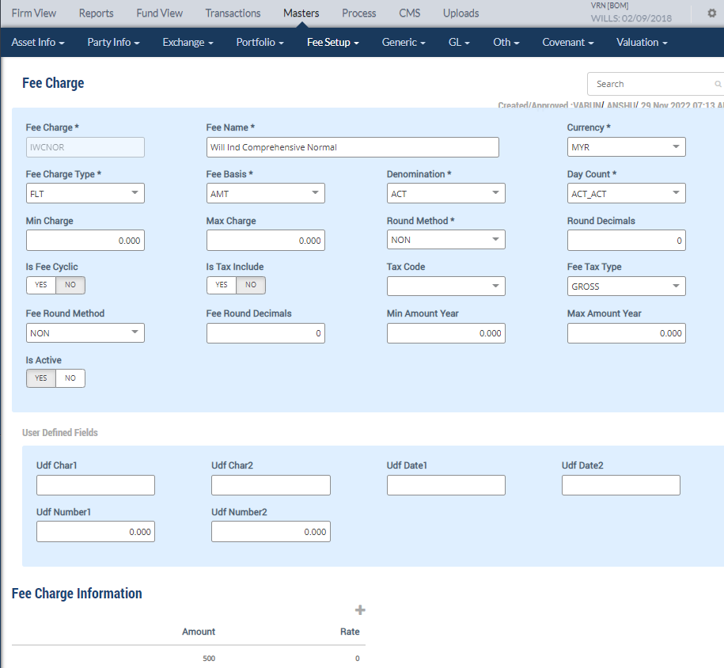

- All fields with * are Mandatory Fields
Fee Charge  (short name) | Maintain Fee Charge short name & Fee Name that can be easily identified or as per user requirement
Fee Name
Fee Charge Type* | Select either Band, Tier, Flat type
Fee Basis* | Select either Amount, Quantity, Percentage, Period-Days, Period-Months , Period-Years
Min Charge | only applicable if Fee Charge Type is “Band” or “Tier”
Max Charge
Round Method * | Select “NON”
Round Decimals | Input “0”
Is Fee Cyclic | If Fees is cyclical select “Yes”, else “No”
Is Tax Include | If Tax included in the Fees, select “Yes”, else “No”
Tax Code | Select Tax Code if applicable, else leave blank
Fee Tax Type | If tax is applicable to the Fee, select either “Gross”, “Net” , else “NA”
Is Active | Always “Yes”, unless the Fee Charge setup is no longer in use, then select “No”
Fee Charge Information | If Fee Basis is “Amount” , input the Fee in “Amount”  If Fee Basis is “Percentage”, input the Fee in “Rate”

- Authorise fee charge upon creation

Trade Fee Setup

- Setup Fee/Commission information via Trade Fee Setup
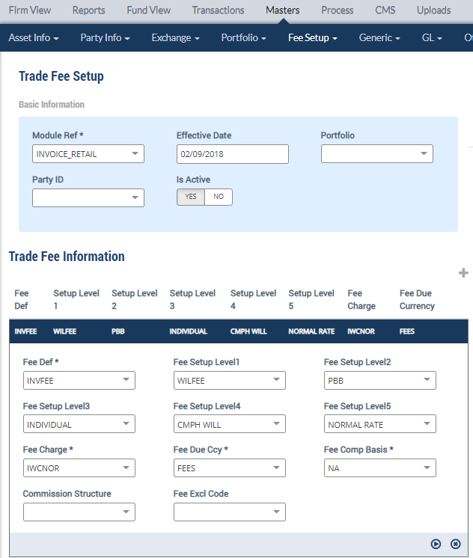

- All fields with * are Mandatory Fields
Module Ref* | Select “Invoice Retail”
Effective Date | The date that this Fee / Commission will be effective
Portfolio | NA. Leave blank
Party ID | NA. Leave blank
Trade Fee Information
Fee Def* | Select either INVCOM (Invoice Collection Retail Commission Fee) or INVFEE (Invoice Retail Fee)
Fee Setup Level1 | Select Types of Fee –  WILFEE –Will Writing Fee  WLCFEE – Will Writing Custody Fee  WLRFEE – Will Writing Rewriting Fee
Fee Setup Level2 | Select Source of Customer - PBB / PMB / Walk In / Other
Fee Setup Level3 | Select Corporate Type – IND / PBTSB
Fee Setup Level4 | Select Will Type – Standard (STD Will) / Comprehensive (CMPH WILL)
Fee Setup Level5 | Select Product Code :  MUTUAL GOLD  NORMAL RATE  RED CARPET MEM  CREDIT CARD  STAFF  REWRITE  50 PLUS SAVINGS  PB PLATINUM CREDIT CARD  VISA INFINATE CREDIT CARD  VISA SIGNATURE CREDIT CARD  PB PARENTS  PB SIBLINGS
Fee Charge* | Select the applicable Fee (setup earlier in the Fee Charge screen)
Fee Due Ccy* | Select “Fees”
Fee Comp Basis* | Select “NA”
Commission Structure | NA. Leave blank
Fee Excl Code | NA. Leave blank

- Authorise Trade Fee Setup upon creation

Invoicing / Maintenance

- Raise Invoice via Invoicing / Maintenance screen
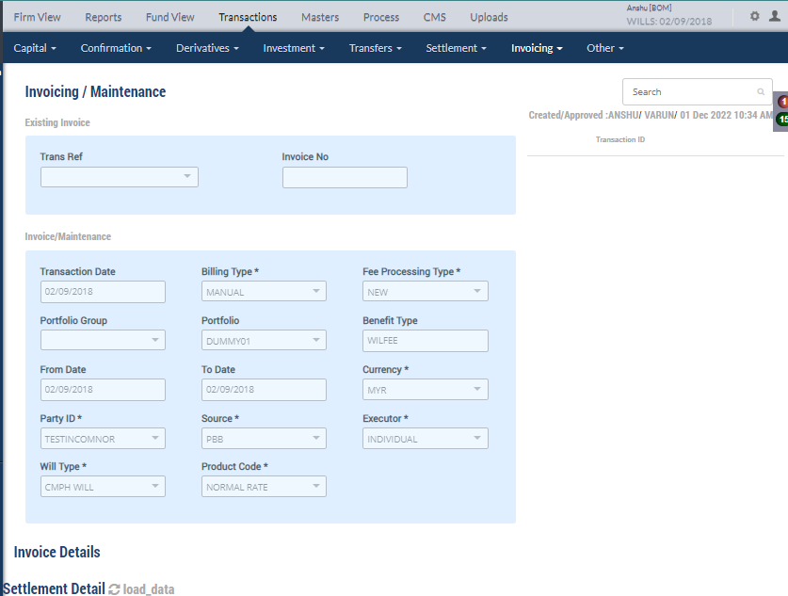
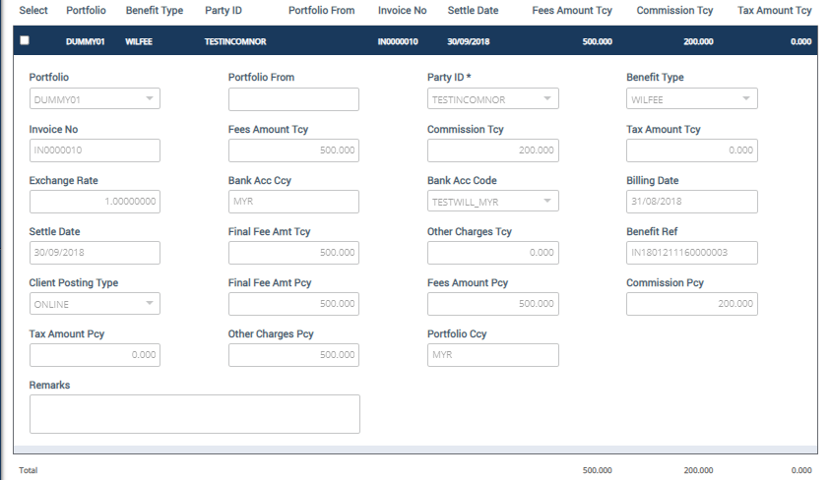

- All fields with * are Mandatory Fields
Transaction Date | The date of Invoice being raised
Billing Type * | Select “Manual”
Fee Processing Type * | Select Fee Type:  ADJPU (Adjustment more), ADJMIN (Adjustment Less), APPEND(Adjustment to existing), NEW (New)
Portfolio Group | Select “Global”
Portfolio | Select Portfolio setup for Wills team
Benefit Type | Types of Fee –  WILFEE –Will Writing Fee  WLCFEE – Will Writing Custody Fee  WLRFEE – Will Writing Rewriting Fee
From Date | Input Period of the Invoice
To Date
Currency * | Select the currency
Source * | Select Source of Customer - PBB / PMB / Walk In / Other
Executor * | Select Corporate Type – IND / PBTSB
Will Type * | Select Will Type – Standard (STD Will) / Comprehensive (CMPH WILL)
Product Code * | Select Product Code :  MUTUAL GOLD  NORMAL RATE  RED CARPET MEM  CREDIT CARD  STAFF  REWRITE  50 PLUS SAVINGS  PB PLATINUM CREDIT CARD  VISA INFINATE CREDIT CARD  VISA SIGNATURE CREDIT CARD  PB PARENTS  PB SIBLINGS
Settlement Detail
Portfolio | Select Portfolio setup for Wills team
Portfolio From | N
Party ID * | Select the Customer for the invoice
Benefit Type | Types of Fee –  WILFEE –Will Writing Fee  WLCFEE – Will Writing Custody Fee  WLRFEE – Will Writing Rewriting Fee
Invoice No | NA, system will generate Invoice No. once the transaction is authorised
Fees Amount Tcy | Fee Amount in transaction currency based on setup in the system
Commission Tcy | Commission Amount in transaction currency based on setup in the system
Tax Amount Tcy | Input Tax amount if applicable
Exchange Rate | NA
Bank Acc Ccy | NA. Auto pull from system once Portfolio is selected
Bank Acc Code | NA. Auto pull from system once Portfolio is selected
Billing Date | Input Billing Date
Settle Date | Input Invoice Settlement Date
Final Fee Amt Tcy | System will pull the Amount in Fees Amount Tcy field
Other Charges Tcy | Input if there is other charges incurred for the transaction
Benefit Ref | NA. Leave blank
Client Posting Type | System auto prompted as “Online”
Final Fee Amt Pcy | NA.
Fees Amount Pcy | NA.
Commission Pcy | NA.
Tax Amount Pcy | NA.
Other Charges Pcy | NA.
Portfolio Ccy | NA.
Remarks | Input Remarks as required by user

- Approve the Invoicing / Maintenance transaction,
- Invoice will be auto settled and reflected in the Invoicing Listing Report and Bank Transaction Report.

Invoicing Listing Report

- All Invoices maintained will appear in the Invoicing Listing Report
- Report can be generated in various format; i.e., HTML, Excel, PDF, CSV…etc

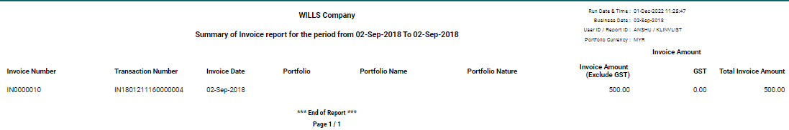

Invoice Settlement

- Invoice Settlement screen is currently not in use by the Wills team as per user requirement. However, in the event manual settlement is required, user can request to enable the function.

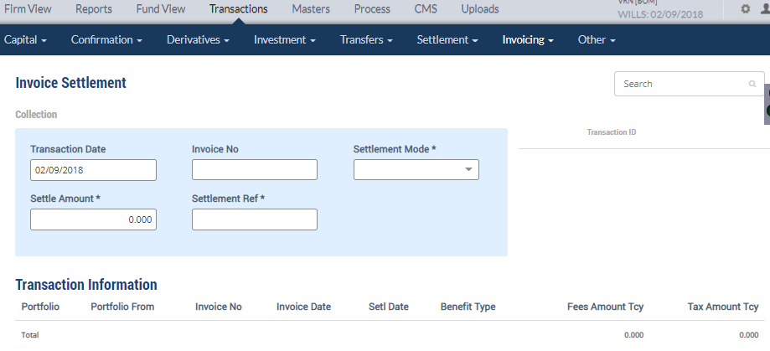

Bank Transaction

- Settled Invoice will be appearing in the Bank Transaction Report
- Report can be generated in various format; i.e., HTML, Excel, PDF, CSV…etc

